|  |
| --- |
| http://josetinoco.com |
| Awful Jumping Platform |
| **Game documentation** |
| Version 1.0  All work (except images and sounds) copyright © 2016 by Joseph Tinoco.  All rights reserved. |
| **Joseph Tinoco** |
|  |



|  |
| --- |
| Oct 19th 2016 |

Contents

I. Game description 4

II. Controls 4

III. Interface Sketch 4

IV. Screen Descriptions 5

V. Characters / Vehicles 5

VI. Enemies 5

VII. Scoring 5

VIII. Sound Index 5

IX. Art / Multimedia Index 6

**Version History**

V1.0.0 – Final version after development. Oct 19, 2016

# Game description

A very common platformer where the Metal Slug sprite moves across a map with enemies and moving platforms. He can jump and shoot enemies.

# Controls

* The player can be moved around the screen with the WASD keys.
* The CTRL key shoots a bullet (assuming the player has ammo).
* The SPACE key jumps.

# Interface Sketch

The wireframe below shows the map design. Player moves from the bottom left in a zig-zag fashion all the way to the top.

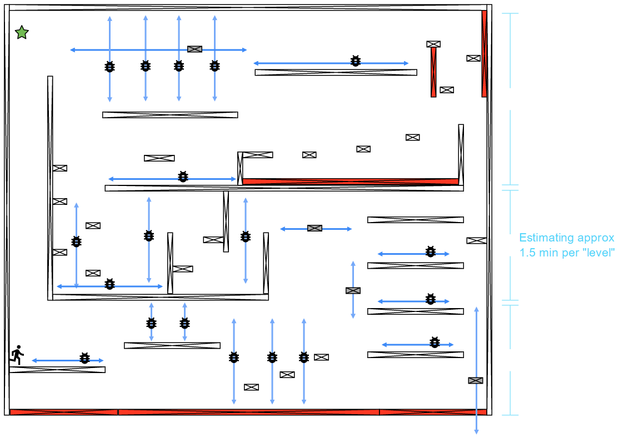

# Screen Descriptions

The game presents an initial screen with the game scene right away. When all lives are spent, player disappears and a “game over” message is shown.

# Characters / Vehicles

The images below show the player sprite sheet.



# Enemies

The image below shows the bat enemy

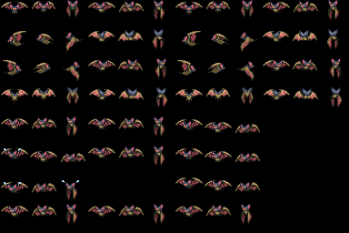

# Scoring

The player gets 100 points for each destroyed enemy. Powerups add 50 points to the score. The final pickup (below) adds 5000 points.



# Sound Index

All sounds were borrowed from the classic “DOOM” game.

|  |  |
| --- | --- |
| Asset name | Description |
| Dsgetpow.wav | Powerup pickup sound |
| Dsdiehi.wav | Screaming sound for when the player loses a life. |
| Dsplasma.wav | Laser-firing sound |
| Dspstart | Escort ship movement sound |
| Dsrlaunch | Explosion sound |

# Art / Multimedia Index

The graphic elements used to build the game are “borrowed” from Metal Slug and from a free theme available at <http://www.ludicarts.com/free-volcano-platform-tileset/>

